Name – Kaung Sat Paing

Student ID – 14399033

Changes -6

Code origin

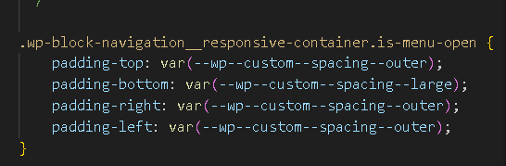

Code Changes

Web Origin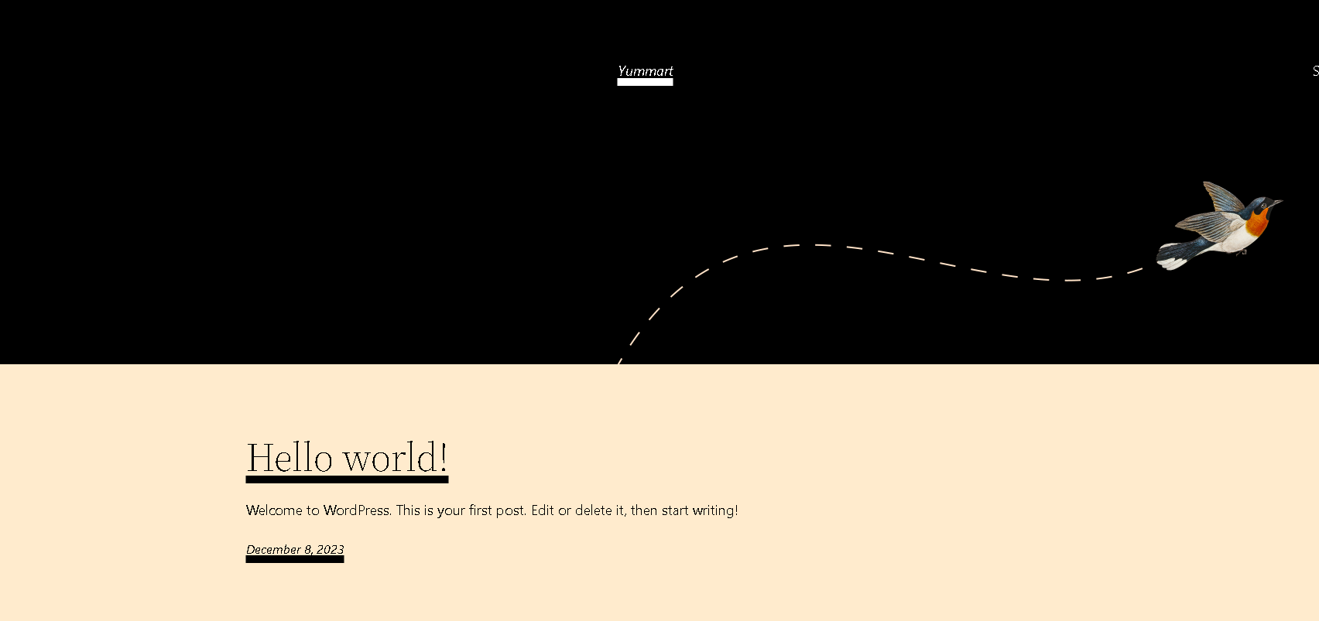

Web Changes

